Approved By: | Board of Trustees/Directors
Approval Date: | 08/04/2025
Next review Date: | 26/04/2027
Policy Holder: | IBTC

Complaints Policy and Procedures

- Introduction

At the IBTC we want to provide an outstanding educational experience for our students and excellent working environment for our voluntary workers. One of the ways in which we can improve what we do is by listening and responding to their views. The college values the feedback that students and voluntary workers provide, and complaints are monitored, evaluated and reported to the IBTC’s Principal who annually reports to the IBTC Board of Trustees/Directors. We aim to deal with complaints in a fair, reasonable and timely manner.
When students sign their Learner Agreement and voluntary workers sign their Volunteer Agreement with the college they are agreeing to the IBTC’s policies and procedures which outline what they can expect from the college and what the college can expect of them.
This policy applies to any person carrying out an agreed function for or on behalf of the IBTC or whose actions will reflect on the IBTC including without limitation: all voluntary workers of the IBTC, students, any person supplying services to the IBTC under a contract for services and any other person engaged for any purpose connected with the IBTC whether on a paid or voluntary basis.
If the complaints or concern involves a child or adult at risk the IBTC safeguarding policy and procedure should be followed. The Complaints Policy is available on the college’s website.
- The objectives of the complaints policy and procedures
The objectives of the IBTC complaints Policy are to ensure:
- A complaint is recognised as a complaint.
- A thorough investigation into complaints is conducted.
- Accurate recording, monitoring and reporting of complaints.
- Support for all those involved in complaints and their management.
- A swift, open process, which is fair to all parties involved.
- A procedure designed to resolve problems quickly and with confidence.
- Accountability for the services a charity provides.
- The complaints procedure is accessible to those who may want to use it.
- Complaints are managed effectively.
- The charity benefits by learning from complaints.

- Defining a complaint
The college defines a complaint as an expression of dissatisfaction, however made, about actions taken or a lack of action, whether justified or not, about any aspect of the functioning of the IBTC including:
- Standards of service.
- Action or lack of action by the college or its voluntary workers.
- Provisions of the college affecting students, visitors or other stakeholders.
- A complainant may be a student, parent, voluntary worker, a visitor to the college or a member of the public.

Where it is unclear whether a communication is a concern or a complaint, it is generally best to err on the side of caution and treat it as a complaint.
The IBTC adopts and follows the guidance of the Charity Commission about complaints which define a complaints procedure or a complaints management system as:
- a formal document agreed by the directors/trustees that outlines the series of actions and the manner in which they will be conducted (including for example the steps and timescales involved) in the investigation of a complaint; or
- an informally agreed procedure for the way in which a charity will deal with complaints it receives about its services. It may be recorded, for example, in the minutes of the meeting at which it was agreed.

Complaints from students will be monitored and administered by the IBTC Students Welfare Manager under the direction of the IBTC Principal. Complaints from voluntary workers, parents, a visitor to the college or a member of the public will be monitored and administered by the Human Resources Manager under the direction of the IBTC Principal.
- Roles and responsibilities
Overall responsibility for this policy and its implementation lies with the IBTC Principal and IBTC Board of Trustees/Directors.
Under the direction of the IBTC Principal, the designated persons for complaints are the HR Manager (for complaints from voluntary workers, parents, a visitor to the college or a member of the public) and Students Welfare Manager (for complaints from students). They will be responsible for the operational processes when dealing with complaints.
In the rare situation where the designated persons are not able to fulfil their role for whatever reason (e.g. sickness) the IBTC Principal will appoint their nominee. In case the Principal is not able to oversee the operational process of the complaint the IBTC Chair of the Board of Trustees/Directors will nominate a person in this role until the Principal is available.
- Who can make a complaint?
- Students who are enrolled on a course at the IBTC.
- Voluntary workers who have enrolled in various roles at the IBTC.
- Parents, a visitor to the college or a member of the public.

It is expected that complaints are made promptly and normally within 6 days of the problem arising. If a complaint is about a voluntary worker, they will be notified and given the opportunity to respond. The IBTC will maintain confidentiality regarding complaints and request that students and voluntary workers do the same.

We would not normally accept a complaint from:
- Former students unless the complaint is received by the IBTC within 28 days of the end date of the course.
- An anonymous source.

Further, we would not normally accept a complaint regarding:
- Complaints about access to information where procedures and remedies are set out in legislation, e.g., Freedom of Information Act, Data Protection Act;
- Matters that have already been fully investigated through this complaints procedure.

The IBTC also has the right not to accept complaints where a complaint is judged by the IBTC Principal and the HR Manager to be frivolous, vexatious, malicious, unreasonable or beyond the college’s capacity to resolve the complaint according to reasonable judgment.
Students may submit a ‘group complaint’. Where a complaint is made by a number of students, the IBTC may ask the group to nominate one student to act as a group representative ensuring that their issue is dealt with promptly and satisfactorily. For further information, contact the Students Welfare Department.
- Complaints and procedures that are not covered in this policy.
Separate appeals procedures exist for the following:
- Academic appeals relating to assessment decisions are covered by the Academic Integrity Policy and Assessment Policy.
- Complaints relating to students’ disciplinary processes are covered by the Students Disciplinary Policy.

- General information about the complaint procedure

A complaint can be received verbally face to face, by phone, by email, or in writing. However, to start the complaint procedure the complaint must be submitted in written format in order to be considered for further processing. All complaints will result in an outcome, whether upheld or whether no further action or a series of recommendations will be made in an attempt to resolve the matter.
All complaint information will be handled sensitively. Only those who need to know will be told, and any relevant data protection requirements will be followed. A complainant may be asked to give consent to personal data being shared with a third party when we are required to do so by law or to protect members of the public from serious harm.
The investigation will be conducted impartially, but where there is any conflict of interest this must be declared with the designated person standing down from the investigation. Therefore, if there is a complaint against the HR Manager or the Student Welfare Manager, the complaint shall be addressed to the IBTC Principal who will appoint a replacement so that the operational processes of the investigation can continue to be monitored and led by the IBTC Principal.
If the complaint is against the IBTC Principal, the complaint shall be addressed to the Chair of the IBTC Board of Trustees/Directors who should bring the issue to be discussed at a special meeting of the IBTC Board of Trustees/Directors.
Any formal meeting arranged with a complainant will usually be conducted by at least two responsible people.
A graphical representation of IBTC policies and procedures is provided in Appendix 2 as a flowchart.

Formal complaint investigation report and content
The designated persons investigating the complaint will complete a Formal Complaint Investigation Report at the end of the investigation. The completed Formal Complaint Investigation Report should contain the following content as a minimum:
- Summary of complaint
- Scope of investigation
- Timeline (if deemed required)
- Investigation findings
- Outcomes
- Recommendations/Actions

The HR Manager or the Students Welfare Manager will produce an Investigation Report signed by the designated person and the IBTC Principal, and a copy will be retained by the IBTC. The complainant has the right to request a copy of this report. Any summary given must ensure compliance with data protection rules and regulations.
Outcomes (For Stages 3 & 4 see Appendix 2)
The outcomes of the Formal Complaint Investigation Report shall be considered by the IBTC Principal. Any outcomes from which further actions might arise after the Review of Formal Complaints Investigation Report in Stage 3, shall be considered by the IBTC Board of Trustees/Directors following Stage 4. Subject to the findings and recommendations, actions may include (but are not limited to):
- Referral of the complaint to another external authority (e.g., Safeguarding Body, Charity Commission) or
- Further disciplinary or intervention process, but only in accordance with the IBTC’s policies.
All copies of correspondence with all parties involved in the investigation will be held in compliance with the UK data protection regulations.

Serious wrongdoings at a charity
For serious wrongdoings at a charity a person might complain to the Charity Commission as an external authority (whistleblowing@charitycommission.gov.uk) if, for example, the IBTC is:
- not doing what it claims to do.
- losing lots of money.
- harming people.
- being used for personal profit or gain.
- involved in illegal activity.

For more information on how to find out what sort of wrongdoing can be reported to the Charity Commission, and how to report it, please visit the website https://www.gov.uk/guidance/report-serious-wrongdoing-at-a-charity-as-a-worker-or-volunteer.

- Data Protection
All complaints received will be dealt with confidentially and in accordance with the requirements of the Data Protection Act 1998 and General Data Protection Regulations 2018.
The IBTC takes privacy concerns seriously. If anyone has any concerns about the way their information is being handled, they should contact the IBTC Data Officer without delay. They can be contacted as follows:
Phone 01444523387
Email address: policies.data@ibti.org.uk
The IBTC will carefully investigate and review any data protection complaints related to the current complaint and take appropriate action in accordance with the IBTC Data Protection Policy and the data protection legislation. The IBTC will keep the complainant informed of major changes during the process of the investigation and the outcome.
If the complainant has any concerns about how their personal data is held during the complaints procedure, they may notify the designated person leading the investigation or the IBTC Data protection officer. In case the complainant is still not satisfied with the outcome after they have notified the designated person or the IBTC Data protection officer, they can contact the Information Commissioner's Office directly at https://jco.org.uk/concerns/ .
- Complaints Procedure

Stage 1- Informal Complaints Procedure (See Appendix 2)
It is worth noting that if the situation allows, the complainant should first seek to address the nature of the complaint directly with the individual as a means of resolving the issue before initiating the complaints procedure. If this is unsuccessful and the matter has not been resolved to the satisfaction of the complainant, then mediation is recommended, and a letter or email should be written to the HR Manager or the Students Welfare Manager who will make an attempt to help in resolving the matter BEFORE a formal complaint is progressed. The written request for mediation regarding the complaint will be acknowledged within 3 working days of receipt, or as soon as possible taking into consideration holidays or time away from the college. The college’s aim is to resolve the informal complaint raised within 10 working days. The designated person needs to write an Informal Complaint Mediation Report.

Stage 2 - Formal Complaints Procedure (See Appendix 2)
If the complaint has not been resolved using the informal complaints procedure, or if it is inappropriate to use the informal procedure because the complaint is of a serious nature, the complainant may make a formal written complaint. If the complainant is a student the complaint should be sent to the Students Welfare Department or if the complainant is a voluntary worker to the HR Manager.
Formal complaints must be made in writing by completing the Complaints Form (Appendix 1).
A complaint should include clear detailed reasons for the complaint and an indication of the resolution or outcome being sought. The complainant may be required to provide copies of any documents upon which they wish to rely upon once their complaint starts to be investigated.
The designated person responsible for managing the complaints process (Students Welfare Manager or HR Manager) administers the formal complaints process and will acknowledge, monitor, and respond to their complaint.
After submitting a written formal complaint, the complainant can normally expect:

Step 1: Complaint acknowledgement (Refer to Appendix 2)
The complaint should be acknowledged within 5 working days of receipt.
Step 2: Complaint investigation, outcome, action and Formal Complaint Investigation Report (Refer to Appendix 2)
An investigation of the complaint will be undertaken by the Student Welfare Manager if the complainant is a student or the HR Manager for voluntary workers and the college’s aim is to complete this stage within 30 working days of receipt of the complaint.
The investigation may involve speaking with relevant individuals and / or looking at relevant documentation. The complainant may be asked to attend a meeting to discuss their complaint. They may bring a friend, relative or other student to accompany them if they have any particular requirements, e.g. if English is not their first language or they have a learning difficulty and require support.
If we cannot send a Formal Complaints Investigation Report within 30 working days of receipt of the complaint, the college will inform the complainant the reason why and let them know when the college will be able to reply in full.
If the complainant is not satisfied with the Formal Complaints Investigation Report, they can request a review. If after 10 working days of receiving the Formal Complaints Investigation Report and the complainant does not request a review, the college will regard their complaint as closed.

Stage 3 - Review of Formal Complaints Investigation Report (See Appendix 2)
The college’s aim is to investigate and resolve all complaints in a fair and reasonable manner. If the complainant is not satisfied with the outcome or any action taken relating to their formal complaint, they have the right to request a Review on one or more of the following grounds:

- New material evidence has come to light which was not reasonably available at the time of the complaint investigation.
- The complainant believes the outcome of the complaint was manifestly unreasonable and/or any resulting action was disproportionate.
- The complaints procedure was not followed.

If the complainant wishes to request a review, they should write a letter or email to the designated person responsible for the case. This must be sent within 10 working days of the date of the college’s Formal Complaints Investigation Report. The complainant must clearly explain the reasons for their request including the grounds upon which it is based and enclose copies of all the documents they wish to rely upon.

Regarding Review of Formal Complaint Investigation Report, the complainant can normally expect:

- Complaint acknowledgement: The designated person (the HR or Students Welfare Manager) and the IBTC Principal will acknowledge the review request within 5 working days of receiving it.
- Complaint review and action: The designated person will consider the request for a review and determine whether it meets one or more of the grounds stated above under Stage 3.

If the request for a review does not meet one or more of the grounds for review, the complaint outcome will not be reviewed. A Completion of Procedures Letter will be sent to the complainant by the designated person to close the matter.
If the designated person determines that the case needs to be reviewed, the complainant will be notified who will lead the review and what the review will involve, including timelines. This may include speaking with relevant individuals and / or looking at relevant documentation. The complainant may be asked to attend a meeting to discuss their complaint. If they have any particular requirements, for example if English is not their first language or they have a learning difficulty they may bring a second person with them.

- Completion of procedure:
The complainant will be informed of the outcome of the review arrangements or completion of procedures normally within 30 working days of receipt of the review request by receiving a Completion of Procedures Letter. The decision of the review is final, and the complaint will not be considered further.
If the college cannot send a full reply within 30 working days of receipt, the complainant will be informed about the reason why and when the college will be able to reply in full.

Stage 4 – Appeal to the IBTC Board of Trustees/Directors or Charity commission (See Appendix 2)
If the complainant remains dissatisfied following the conclusion of a Review of Formal Complaints Investigation Report and the receipt of a Completion of Procedures Letter, they may be able to take the matter further by escalating their complaint to the IBTC Board of Trustees/Directors or with the Charity Commission.
If the complaint is sent to the IBTC Board of Trustees/Directors, they will acknowledge the complaint request within 7 working days of receiving it and they will deal with the complaint or within 10 working days nominate an appropriately qualified independent mediator to investigate the complaint further. Either the nominated person or a member of the Board of Trustees/Directors will contact the complainant within 10 working days from the acknowledgment of the receipt, and if necessary, arrange a meeting.
All complaints procedures should be completed within 40 working days of the receipt of the complaint.
The IBTC Board of Trustees/Directors will send a Final Completion of Procedures Letter to the complainant. This letter will confirm what action is to be taken, or why the complaint has been rejected.
If all attempts to resolve the matter internally are still deemed unsatisfactory, the complainant may be able to appeal to the Charity Commission, subject to their remit.
The complainant will usually need to exhaust the IBTC Complaints and Procedures policy and have received the Final Completion of Procedures Letter before they can escalate their complaint to any external organisation.
If during the process of dealing with the complaint according to the Complaints Policy and Procedure, it becomes clear that an issue is of a disciplinary nature the IBTC Disciplinary Policy and Procedure should be referred to and followed.
- Timescales of the stages: (See Appendix 2)
Stage 1: Informal Complaints Procedure: Maximum 10 working days
Acknowledgment within 3 working days.
The Informal Complaint Mediation Report within 10 working days.
Stage 2: Formal Complaints Procedure: Maximum 30 working days
Acknowledgment within 5 working days.
Formal Complaints Report within 30 working days.
Stage 3: Review of Formal Investigation Report: Maximum 30 working days
Acknowledgment within 5 working days.
Completion of Procedures Letter within 30 working days

Stage 4: Appeal to the IBTC Board of Trustees/Directors or the Charity Commission: Maximum 40 working days
Acknowledgment within 7 working days.
If necessary, nominate an appropriately qualified independent mediator to investigate the complaint further within 10 working days.
Final Completion of Procedures Letter within 40 working days.

- Mechanisms for feedback
Constructive comment for the continued improvement of this policy is welcomed and should be forwarded to our Data Protection Officer at policies.data@ibti.org.uk.

APPENDIX 1:

COMPLAINTS FORM

Please follow the structure of this form and provide the information required under each point. Please submit any additional documentation you think is necessary along with this form.

- Date of completing Complaints Form:
- Name and surname of the complainant:
- Contact telephone number:
- Email address:
- Residential address:
- Name of designated person (or their nominee), the IBTC Principal and a member of the IBTC Board of Trustees/Directors as appropriate:
- Whom your complaint is about:
- Date when the incident happened:
- The nature of your complaint:
- Describe the complaint in detail:
- Give an indication of resolution or outcome you seek (e.g. Are you seeking a verbal or written apology?):
- Additional information:
- Signature of complainant:

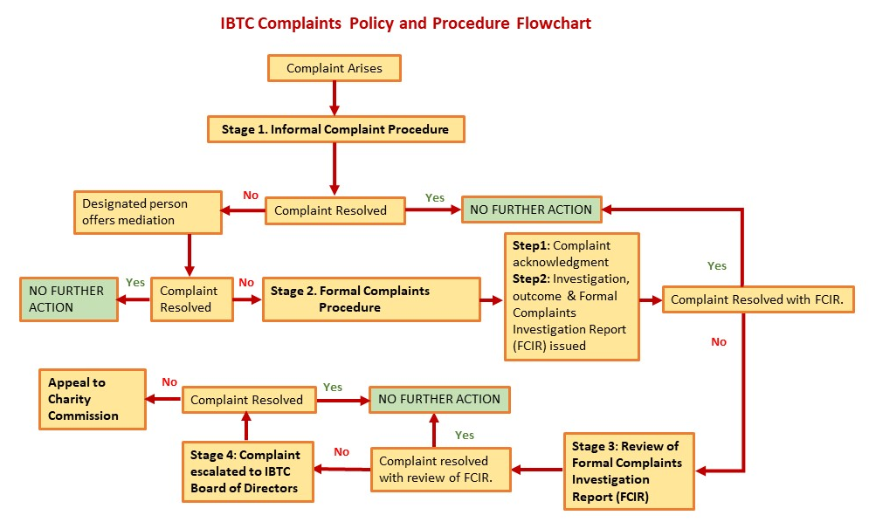
APPENDIX 2:

The independent regulator of charitable fundraising in England, Wales and Northern Ireland, (2023) Complaints handling guidance for charities and third party fundraising organisations https://www.fundraisingregulator.org.uk/sites/default/files/2018-07/Complaints-handling-guidance.pdf, (Accessed, 31.10.2023)
Charity Commission, (2006) Cause for Complaint? How charities manage complaints about their services. [online]. https://assets.publishing.service.gov.uk/media/5a7c99d0e5274a7b7e3218a0/rs11text.pdf, (Accessed, 31.10.2023)
GOV.UK, (2023) Complain about a charity. [online]. https://www.gov.uk/guidance/report-serious-wrongdoing-at-a-charity-as-a-worker-or-volunteer , (Accessed, 31.10.2023)

